FIGCollection

System Architecture

DOCUMENT  Architecture review |  | BASIS  Repository implementation |  | REVIEW DATE  September 17 2026

Prepared for | FIGCollection engineering and operations
Coverage | Eight core services and Angular administration console
Source | FIGCollection solution and database scripts
Purpose | Architecture, service responsibilities, data model and operational features

1 Introduction
FIGCollection is a distributed, configuration-driven automated trading platform. It separates market data acquisition, technical analysis, signal execution, broker connectivity and system administration into independently hosted services. A central controller provides service discovery and request routing, while SQL Server stores configuration, market history and execution state.
The defining architectural pattern is a combination of service-oriented request routing and database-driven event processing. Services locate each other by role or service ID through FIGControllerSvc. Price and signal changes are communicated through SQL Event records and SqlDependency notifications. The controller therefore mediates service calls, while the database coordinates much of the trading pipeline. [S1–S4]

System boundaries
The core platform contains the seven services described by the system owner, plus FIGAlertSvc found in the solution. FIGAutoTraderAdminConsole is the Angular user interface. IBKRProvider and RootsIdentity are supporting libraries, not additional independently hosted services in this core topology. Interactive Brokers is the implemented brokerage integration.
FIGServiceManagerSvc in the business description corresponds to FIGServiceMgrSvc in the repository. FIGAutoTradeSvc corresponds to FIGAutoTraderSvc. Some namespaces and documentation retain FIGSignalExSvc or FIGAutoTradeExSvc names; the current project and assembly names are used throughout this report.

Architectural conclusions
• The controller supplies location transparency through a persistent SignalR connection and a durable Device registry. It does not implement a durable message queue or a general load-balancing policy.
• The trading and broker services persist related but separate order records. Acknowledgement, submission, partial fill and final fill are different stages of the order lifecycle.
• Shared SQL schemas and the FIGCommon repository layer create operational coupling between services, even though the services are separately deployed.
• The small service manager uses a generic host and dispatches commands in process, avoiding a local web server. Software updating remains a planned capability.

Document guide
Sections 2 and 3 explain communication and execution flow. Sections 4 through 12 describe each service and the console. Sections 13 through 16 document the database model. Sections 17 through 20 cover contracts, operations and review findings. The final section provides source locations for technical verification.

2 Service architecture
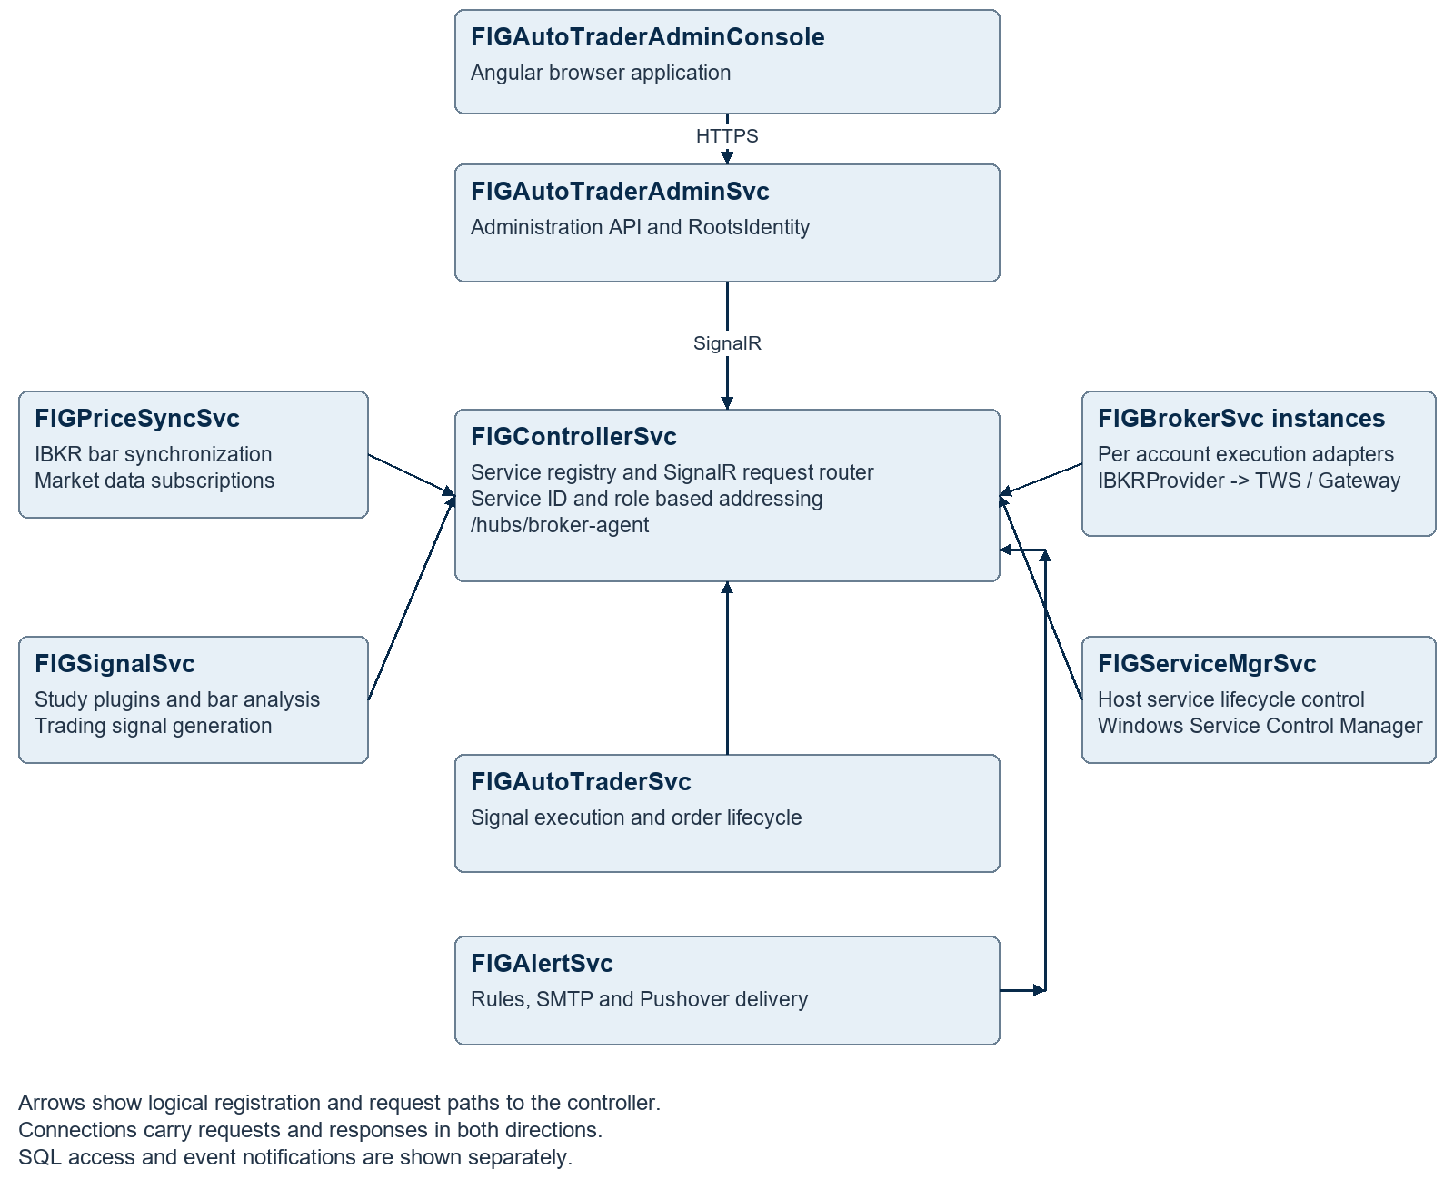
Figure 1 Core service topology and controller mediated communication
Each participating service opens an authenticated outbound connection to the controller hub and registers its identity, role, machine information and connection ID. Routed traffic returns over that connection. Distributed broker and service-manager instances can therefore be addressed without callers configuring each instance’s network endpoint. [S1–S3]
Browser traffic reaches the administration backend directly. SQL Server, IBKR TWS or Gateway, and notification providers are external dependencies rather than targets of controller routing. The diagram represents logical connectivity rather than a required number of machines.

3 Market data and trade lifecycle
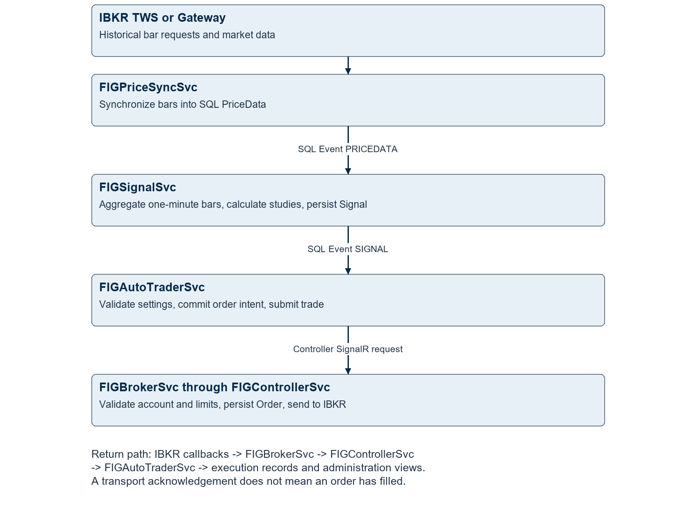
Figure 2 Database driven analysis followed by controller routed execution
Database triggers update Event records for changes such as PRICEDATA and SIGNAL. EventMonitorService subscribes to SQL query notifications, reloads recent event state and invokes local subscribers. Services read the underlying business records to determine the work required. The Event table is a change-notification mechanism, not an immutable event-sourcing log. [S4, S18]
The execution service commits its local order intent before dispatching to the broker. Broker callbacks subsequently reconcile execution state. This design supports asynchronous progress, but a lost acknowledgement remains an ambiguous outcome until broker state is checked. [S9–S12]

4 FIGControllerSvc
FIGControllerSvc is the platform’s service registry and application-level request router. It implements location-transparent communication: a caller supplies a functional role, a specific service ID, or both, and the controller resolves the destination to a connected SignalR client. This is a centralized service mediation pattern. [S1–S3]

Registration and discovery
ClientAgentHub exposes /hubs/broker-agent and requires the SVC or Admin role. RegisterService updates the Device record with service name, type, machine, role, version, address and active connection ID. Existing disabled devices remain disabled and their registration is rejected. Disconnect processing clears the stale connection reference without deleting the service identity.

Request routing
RouteRequestFromClient accepts a ControllerRouteRequest. Role-only routing selects the first record returned by GetDevicesByRole. ID-only routing resolves that Device directly; supplying both ID and role adds a role consistency check. Disabled or missing services are rejected, and a remote service without an active connection is treated as unreachable.
For a remote target, RouteAsync invokes the client method RouteRequest and relays its ControllerRouteResponse. A request targeting the controller itself is forwarded to its local HTTP endpoint. The router imposes a 60-second deadline. The shared client normally forwards incoming requests to the target service’s local Kestrel API with the supplied bearer token.

Features and operational implications
• Persistent duplex connections support service callbacks as well as request and response exchange.
• Request IDs correlate the request and response; an explicit transport envelope preserves HTTP status and response body.
• Reconnect and re-registration are implemented by the shared ClientSignalRService.
• Role selection is first-match routing. It should not be described as round-robin balancing, leader election or automatic failover.
• The hub and Device database are central dependencies. Persistent registry rows alone cannot restore active SignalR connections after a controller restart.

Principal implementation
ClientAgentHub owns registration and routing. ClientSignalRService implements the service-side transport. ApiServiceBase supplies authenticated API invocation, token caching and one immediate retry for eligible authentication failures. Core files: [S1–S3].

5 FIGPriceSyncSvc
FIGPriceSyncSvc is a market data ingestion and bar synchronization service. It connects through the provider abstraction to IBKR, loads configured data sets and persists OHLCV market bars into the trading database. Its main persistence path uses scheduled historical-bar requests to catch up and refresh data. [S5, S6]

Processing model
PriceSyncService resolves data sets and provider interval definitions, queries the last stored bar, and schedules synchronization and update tasks. HistoricalData converts provider bars into PriceData records. SyncPrices separates revisions to existing bars from newly appended bars, uses upsert and bulk append operations, and then reloads the database watermark.
The service includes provider restart coordination, database retry scheduling, contract lookup, futures contract detail retrieval and market-data subscription methods. PriceChangeMonitorService listens for price deletion events so affected data sets can be refreshed. Market scheduling helpers calculate synchronization times from interval boundaries and schedule configuration.

Inputs and outputs
Direction | Data or dependency
Reads | DataSet, Ticker, Interval, provider configuration and latest PriceData time
External | IBKR historical data, instrument lookup and market-data interfaces
Writes | PriceData revisions and new OHLCV bars
Downstream | SQL PRICEDATA event notifications consumed by FIGSignalSvc

Implemented scope
SyncPrices currently performs database synchronization only when Ticker.SecurityType is FUT. The generic ticker/provider models accommodate other security types, but that does not establish end-to-end stock bar persistence in this path. Live subscription helpers exist; the separate MarketDataTrackerService implementation is commented out and the market-data hub mapping is disabled in Program.cs.
For architecture and operations, distinguish scheduled bar synchronization from a fully active tick-to-browser streaming pipeline. Price freshness depends on provider availability, configured schedules and successful database writes. Bar timestamps and revisions should be monitored because the study service consumes the persisted bars.

6 FIGSignalSvc
FIGSignalSvc is a stateful technical-analysis and trading-signal generation engine. It transforms stored price bars into configured study collections, persists calculated study history, and derives strategy entry and exit signals. The calculation engine is extensible through versioned study plugins. [S7, S8]

Bar processing and state
PriceMonitorService performs initial study processing at startup and subscribes to PRICEDATA events. It accepts data sets whose IntervalId is "1" and processes enabled StudyCol rows for the matching ticker. ExecStudySet loads one-minute prices and aggregates them to the StudyCol interval using Interval.IntervalLen in seconds.
The engine rebuilds sufficient history for study warm-up, processes new bars incrementally and revisits recent records. Study outputs are serialized into StudyHistory.Studies as JSON alongside OHLCV values. In-memory histories and plugin instances retain calculation state; database history supports restart reconstruction.

Signal generation
StudySignal reads a strategy-specific value named <Strategy>_SIDE. A nonzero side opens a signal when none is active. A side change closes the previous signal and creates the opposite signal. A zero side closes the active signal. Signals receive a GUID tag and carry strategy, side, start/stop time and price. Study-history writes and signal upserts are grouped in a SQL transaction.

Plugin contract
StudyPluginCatalog scans plugin.json manifests under StudyPlugins:Path. It checks the plugin API version, confines the assembly path to the plugin directory, loads an IStudyCollectionFactory and resolves it by StudyCol.ColType. Shared contracts come from FIG.Studies.Core; common indicators come from FIG.Studies.Common. Replacing an active plugin requires a restart because instances retain replay and smoothing state.

Important details
• The configured study interval is derived from persisted one-minute data, so availability and correctness of that base data are prerequisites.
• ColParams stores collection parameters; StrategyConfig associates a strategy name with its collection.
• Historical replay, a revised in-progress bar and a newly completed bar have different processing consequences.
• Transaction failures in StudySignal are caught and logged after in-memory progress may have advanced. Recovery of the last processed bar should be tested explicitly.

7 FIGAutoTraderSvc
FIGAutoTraderSvc is the signal execution orchestrator and order lifecycle coordinator. It maps strategy signals to configured trading allocations, determines opening or closing quantities, commits execution intent and delegates broker execution to the BOT’s designated broker service. [S9, S10]

Configuration and execution
AutoTradeManagementService maintains a worker for each running AutoTrade configuration and restores configurations marked Started at service startup. Each configuration identifies the strategy, ticker, BOT, quantity and execution state. SignalMonitorService listens for SIGNAL changes and debounces bursts into a scheduled WakeupAll; each worker then evaluates its own current database state.
AutoTradeLiveService creates AutoTradeSignal records that associate a strategy signal with an execution configuration. Entry quantity takes its direction from Signal.Side and its magnitude from AutoTrade.Qty. Closing logic uses actual filled quantity or a manual quantity adjustment. Expiry checks can reject stale entry and exit signals, and an inactive BOT blocks new entries.

Persistence and concurrency
Opening and closing order intent is written transactionally before the order ID is added to the dispatch list. A per-AutoTrade priority lock serializes local processing and status updates; a process-wide semaphore limits concurrent processing slots to three. Transient SQL errors, duplicate conflicts and missing-signal postconditions have bounded retry handling. These in-memory locks coordinate one process; they do not elect an owner across multiple service instances.

Broker communication and recovery
OrderManagementService resolves Bot.BrokerServiceId and AccountId, converts ticker metadata into an order request, and submits only orders still marked NEW. FigBrokerAPIService routes to the Broker role plus the explicit service ID. After acknowledgement, a delayed status check supplements callbacks. Status reconciliation records fills, average price, broker reference and failure reasons.
The generated automatic orders are market orders. The outbound request sets TimeInForce to GTC and StopPrice to zero. Generic request DTOs should not be interpreted as proof that every order type or protective-order policy is implemented by this automatic execution path.

Configuration issue requiring attention
The fallback signal-expiry value in AutoTradeLiveService is 10020 minutes, while nearby comments say 20 minutes. Explicit configured values take precedence, but an unset or invalid setting uses the much longer code value. Confirm and correct the intended default before relying on the expiry safeguard. [S9]

8 FIGBrokerSvc
FIGBrokerSvc is a distributed execution gateway and broker adapter host. Each instance is assigned a service identity and configured broker accounts. It validates trading instructions, persists its own order ledger and translates provider-neutral requests into IBKR operations through IProviderService. [S11–S13]

Pretrade validation
OrderService resolves the enabled BrokerAccount from AccountId and verifies that AccountServiceId matches the current instance. It resolves the configured provider and instrument, checks whether the account permits that ticker, and evaluates long and short position limits using current and pending position information. Orders beyond those limits receive explicit ignored status codes.
The service also checks for a prior order with the same account, OrderTagRef and OrderTag. It creates a broker-side Order record before calling the provider. The broker database ID is passed as the provider transaction reference, while OrderRefId preserves the execution service’s client request reference.

Asynchronous execution
OrderService supports waiting and no-wait submission paths, cancellation, instrument lookup and price snapshots. OrderTrackerService supervises provider tracking and callback consumption, processes errors, open/completed orders and status changes, updates the broker ledger, and forwards status through ATSApi to the ATS role via the controller.
IBKRProvider uses the IB API socket connection to TWS or Gateway. It manages connection/reconnection, historical requests, order submission, position tracking and callback normalization. This adapter boundary makes additional integrations architecturally possible; IBKR is the currently implemented brokerage provider.

Deployment and consistency
• A broker service can be deployed close to its configured TWS/Gateway session while remaining reachable through the controller connection.
• Account and ticker limits belong to the broker configuration, providing a second validation boundary after the execution service’s decisions.
• The broker and trading databases have separate ticker IDs and order IDs. Correlate using account, contract metadata, request references and broker references.
• Duplicate checking before insertion is a useful guard, but should not be described as an end-to-end exactly-once execution guarantee under concurrent calls or ambiguous network failure.
• Status callbacks target the ATS role, so adding multiple execution-service instances requires an explicit routing and ownership design.

9 FIGAutoTraderAdminSvc
FIGAutoTraderAdminSvc is the administration application backend and operational control API. It exposes authenticated web endpoints for configuration, monitoring, reporting and remote service operations, and serves as the backend for the Angular administration console. It combines direct repository operations with controller-mediated calls to runtime services. [S14, S15]

Administrative capabilities
• Manage AutoTrade definitions, duplicate configurations, start or stop groups, inspect execution status and adjust manual quantities.
• Manage tickers, intervals, data sets, study collections, strategy mappings, settings and study/signal history.
• Inspect broker accounts, permitted tickers, position limits, prices and orders; route manual broker operations.
• Manage devices, retrieve remote logs, and issue host service start/stop/status commands through ServiceMgrApi.
• Manage alert rules and recipients, view operational alerts, compile reports and validate database configuration.

Identity and authorization
Program.cs hosts RootsIdentity, which configures ASP.NET Core Identity, an Entity Framework identity context and JWT-based authentication. Administrative controller methods commonly require Admin or SuperAdmin roles. The backend is therefore also an authentication dependency for services configured to use its identity endpoints.

Monitoring and request mediation
ATSMonitorService periodically retrieves the device list, probes service reachability, maintains ConnectionStatusStore and pushes changes through /hubs/ATS_Monitor. The implementation uses a ten-second polling interval, an offline threshold of two failures and periodic forced status publication. DeviceMonitorService and SQL events also support administration updates.
ATSApiService, BrokerApiService, ServiceMgrApi and LogViewerApi encapsulate routed calls. Many configuration endpoints read or write SQL through MainRepo. This backend is not simply a transparent reverse proxy; it contains application-specific orchestration, validation and reporting logic.

Operational boundaries
Configuration persistence, a running worker and a live broker session are separate states. User-interface success should be interpreted using the returned operation and execution status. Database maintenance and manual trading endpoints deserve dedicated audit records and least-privilege access. IdentityModelEventSource.ShowPII is enabled in Program.cs and should be reviewed for production logging. [S14]

10 FIGAutoTraderAdminConsole
FIGAutoTraderAdminConsole is an Angular single-page administration application. It provides the operator experience for configuration, monitoring and intervention, while the backend enforces access to trading and system-management operations. The repository package declares Angular 22.0.4, RxJS, CoreUI, PrimeNG, JWT helpers, SignalR and lightweight-charts. These are repository dependency declarations. [S16]

Functional areas
Area | Visible application capability
Dashboard and devices | Service/device status, device tree and remote log viewing
Automated trading | AutoTrade lists, active signals and archived signals
Broker administration | BOT tree and associated account configuration views
Analysis | Price and study charts using the charting application components
Alerts | Overview, events, rules and recipients; unsaved-change guards on editor routes
System administration | User administration and system/database administration views

Interaction model
The console calls the administration API for data and operations. SignalR provides server-originated status updates, complementing normal request/response interactions. It does not connect directly to the broker execution API or Windows Service Control Manager.
The route map contains login, dashboard, devices, autotrade, users, bots, charting, system administration and active/archived signal views. The detached log viewer has its own route. Client-side navigation is a presentation concern; backend role checks remain the security boundary.

Product distinctions
Start or stop of an AutoTrade worker is different from starting or stopping the Windows service hosting the execution engine. Likewise, a connected service is not evidence that its market data is fresh or that every configured broker account is ready to trade. The console should present these states separately.
Some routes and supporting components reflect ongoing development. For example, the servicadmin route currently points to ChartsComponent. The active market-data hub mappings in the service programs should determine documented real-time features rather than the mere presence of a component or hub source file.

11 FIGServiceMgrSvc
FIGServiceMgrSvc is a host-level service lifecycle agent. Its responsibility is deliberately narrow: query, start and stop configured Windows services, and expose related diagnostics. It uses a generic .NET host with a persistent controller connection, rather than an ASP.NET Core web host. [S17]

Lightweight dispatch architecture
ServiceManagerSignalRService derives from the shared controller client and overrides SendToLocalController. Incoming routed requests are dispatched directly to ISignalRController implementations. SignalRDispatcher resolves the route to ServicesController, PingController or LogController, then returns a normal controller response envelope. A local Kestrel endpoint is unnecessary.

Service lifecycle controls
ManagedServiceController wraps System.ServiceProcess.ServiceController. Start and Stop require the requested service name to be in ServiceManagerConfig.ManagedServices. Operations are idempotent for already running or already stopped services and wait up to 30 seconds for the requested state. Querying all statuses enumerates the configured list; a single-service GetStatus currently bypasses the allow-list check.
Operation | Internal routed endpoint
List managed states | GET /services
Query one service | GET /services/{name} or /services/{name}/status
Start service | POST /services/{name}/start
Stop service | POST /services/{name}/stop

Reliability and security boundaries
Keeping this agent small reduces the amount of application code required to recover other services. However, remote access still depends on controller connectivity and authentication. If the controller itself is stopped, the same controller route cannot be used to start it again. Windows recovery configuration or an independent host administration path is needed for that case.
The in-process dispatcher does not show a per-command validation of the forwarded request token. Its trust boundary is therefore different from services that forward into an HTTP endpoint with authorization middleware. Review which authenticated controller clients may send lifecycle commands, and bind service identity and command permissions explicitly.

Planned capability
Software deployment and updating are part of the stated future direction. The reviewed manager implements lifecycle and log commands; package verification, staged replacement, rollback and update orchestration should be documented as future work rather than present functionality.

12 FIGAlertSvc and shared components
FIGAlertSvc is the centralized operational alert classification and delivery service. It accepts structured log alerts, enriches them with device identity, evaluates configured rules and dispatches notifications to subscribed recipients through SMTP or Pushover. It is an additional core service present in the codebase. [S19]

Alert lifecycle
AlertProcessingService persists received alerts, loads enabled classification rules and selects the highest-severity matching rule. Friendly messages are generated from templates. AlertDispatchService handles immediate and scheduled delivery; recipient enablement, delivery channels, time-zone formatting and maximum alert age influence eligibility.
Non-immediate messages can be batched, repeated formatted messages condensed, and oversized content split. An alert is marked sent only after all required sends succeed. A partial failure can cause previously successful recipients or parts to receive a retry because there is no persistent per-recipient delivery ledger. Notification-provider acceptance is not proof that an operator read the notification.

Shared runtime components
Component | Role
FIGCommon | DTOs, controller client, repository access, scheduling, SQL event monitoring, logging, status codes and configuration utilities
IBKRProvider | Broker/market-data adapter, IB API socket client, position tracking and callback translation
RootsIdentity | Hosted authentication and account management using ASP.NET Core Identity and JWT
FIG.Studies.Core | Study collection contracts, base types and plugin interfaces
FIG.Studies.Common | Reusable technical-study implementations and calculation support

Alert reliability boundary
LogAlertRouter forwards eligible in-process log records through the controller. Failed forwarding is logged locally without requeueing. Its input is not a durable distributed outbox. Separately, the trading schema has SystemAlert records and the execution service includes SystemAlertMonitorService. The signal program’s direct LogAlertRouter registration is commented out, so alert coverage must be assessed by producer path. [S4, S19]

13 Database architecture
SQL Server provides durable configuration, time-series bars, computed study history, signal state, execution ledgers, service registration and identity data. The architecture uses several logical database domains, with shared repository access rather than strict database ownership by one service. [S18–S21]
Domain | Principal data | Primary users
Trading | Ticker, Interval, DataSet, PriceData, StudyCol, StudyHistory, StrategyConfig, Signal, AutoTrade, execution orders, Bot, Device, Event | Controller, PriceSync, Signal, AutoTrader and Admin
Broker | BrokerAccount, BrokerAdapter, broker Ticker, BrokerAccountTicker and Order | Broker service and routed administration
Alerts | Alert, rules, recipients, subscriptions, delivery policy and Event | Alert service and administration
Identity | AspNetUsers, roles, claims, logins, tokens and ValidationToken | RootsIdentity hosted by Admin

Relationships and diagram notation
Figures 3 through 6 separate the schema into readable domains. Solid arrows run from a referenced parent to its child and represent foreign keys declared in the SQL scripts. Dashed arrows represent application/model relationships that are not declared as foreign keys in the supplied DDL. A parent can have zero or many child rows; each non-null foreign key identifies one parent.
The trading and broker databases each define a Ticker table. Their numeric IDs are local to their database. Bot.AccountId corresponds logically to BrokerAccount.AccountId, and Bot.BrokerServiceId identifies a registered Device. AutoTradeSignalOrder.RequestRef is passed to the broker as OrderRefId. These cross-domain associations are not cross-database foreign keys.

Database logic is part of the application
MainRepo and BrokerRepo issue SQL and stored-procedure calls. Triggers maintain Event notifications for price, signal, BOT, device and execution changes. Views and procedures also supply reporting and archive behavior. Deployment therefore needs coordinated application binaries, schema changes, indexes, procedures and trigger definitions.
The broker VOrder view references an OrderStatusCode table using the literal database name FigAutoTrader, while installer scripts use fig_autotrader. Resolve that naming dependency for each deployment. Schema snapshots and migrations also differ, so the diagrams describe repository definitions rather than asserting the installed database state.

14 Market data and study schema
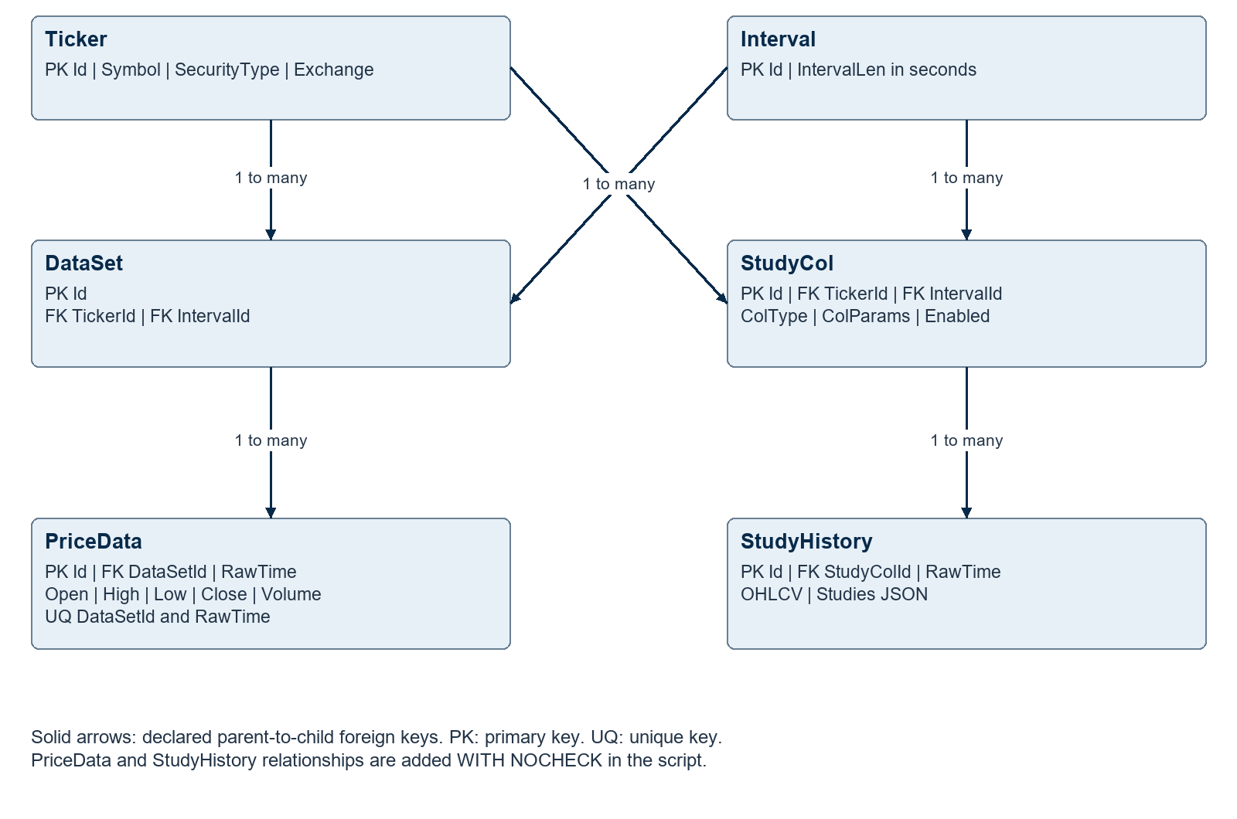
Figure 3 Market data and technical study entity relationships

Entity responsibilities
Ticker defines contract metadata, security type, exchange, currency, tick size and contract size. Interval defines the bar duration. DataSet identifies a ticker/interval combination; PriceData stores OHLCV bars and enforces uniqueness on DataSetId plus RawTime. [S18]
StudyCol binds a ticker and interval to a study plugin type and parameter document. StudyHistory stores the resulting OHLCV and calculated Studies JSON per collection and time. StrategyConfig maps a globally keyed strategy name to StudyCol.
PriceData.DataSetId and StudyHistory.StudyColId are declared using WITH NOCHECK in the snapshot. Existing-row validation should be inspected in the deployed catalog. Several epoch time fields are SQL int values; capacity planning should include the signed 32-bit epoch boundary rather than assuming all timestamps use bigint.

15 Signal and execution schema
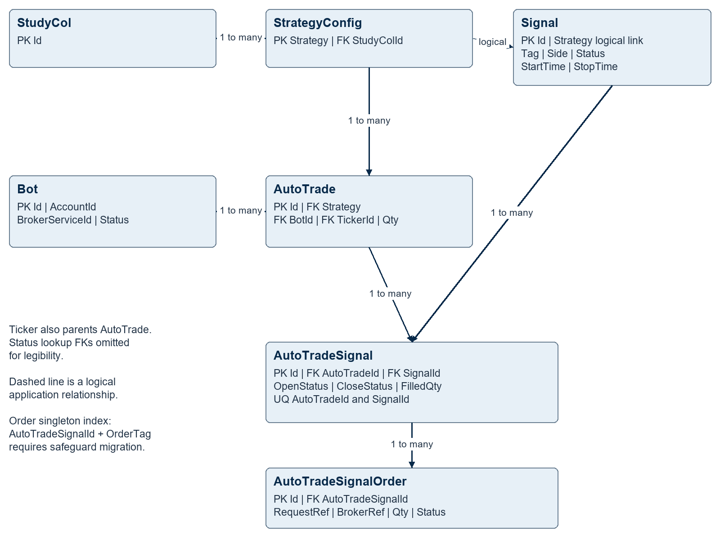
Figure 4 Configuration, signal allocation and order intent relationships
Signal describes a strategy opportunity; AutoTrade describes how a configured allocation follows that strategy. AutoTradeSignal records the resulting execution state for the pair, including original, filled and manually adjusted quantity. AutoTradeSignalOrder stores individual OPEN/CLOSE order intent and request correlation. AutoTradeSignalArchive preserves denormalized historical context for reporting. [S18]
Signal.Strategy is used as an application relationship to StrategyConfig.Strategy; the snapshot does not declare that foreign key. Status tables supply declared references for Signal.Status and execution order status. The safeguard migration adds uniqueness for AutoTradeSignalId plus OrderTag and refuses to silently delete existing duplicates.

16 Broker alerts and identity schemas
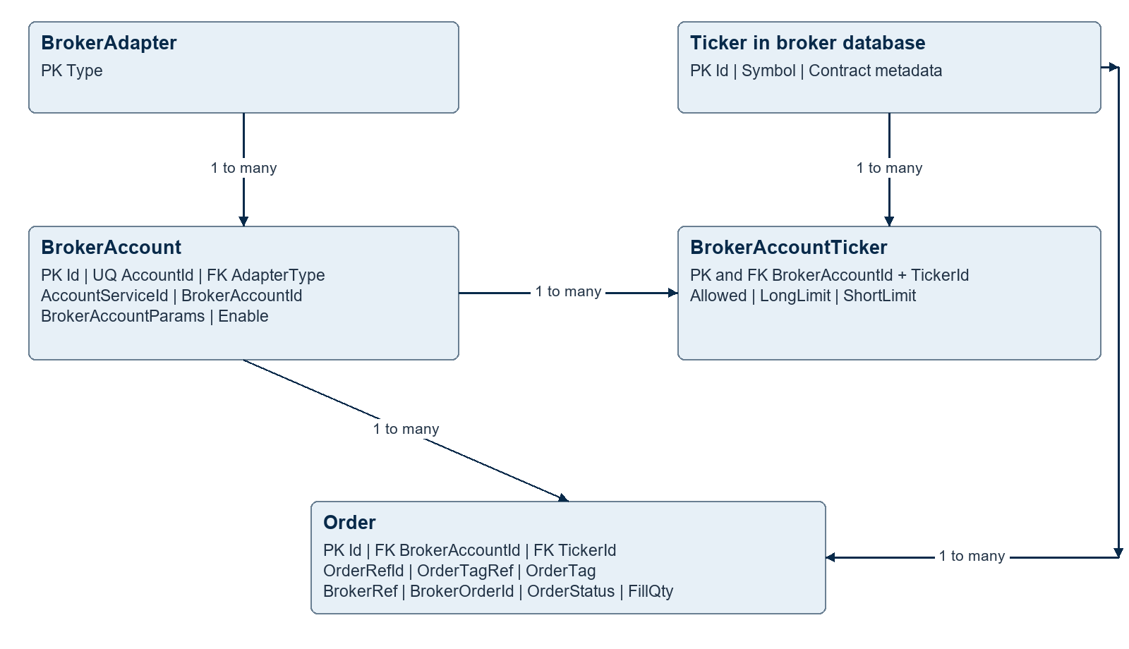
Figure 5 Broker account configuration and execution ledger
BrokerAccount binds the logical account to an adapter, external broker account and owning service. BrokerAccountTicker is the account/instrument permission and position-limit junction. Order stores provider submission, cancellation, fill, completion and correlation details. All solid relationships above are declared in the broker DDL. [S20]
The broker’s order record is complementary to AutoTradeSignalOrder: one tracks broker execution, the other tracks strategy-driven intent. Database transactions do not span the external brokerage side effect.
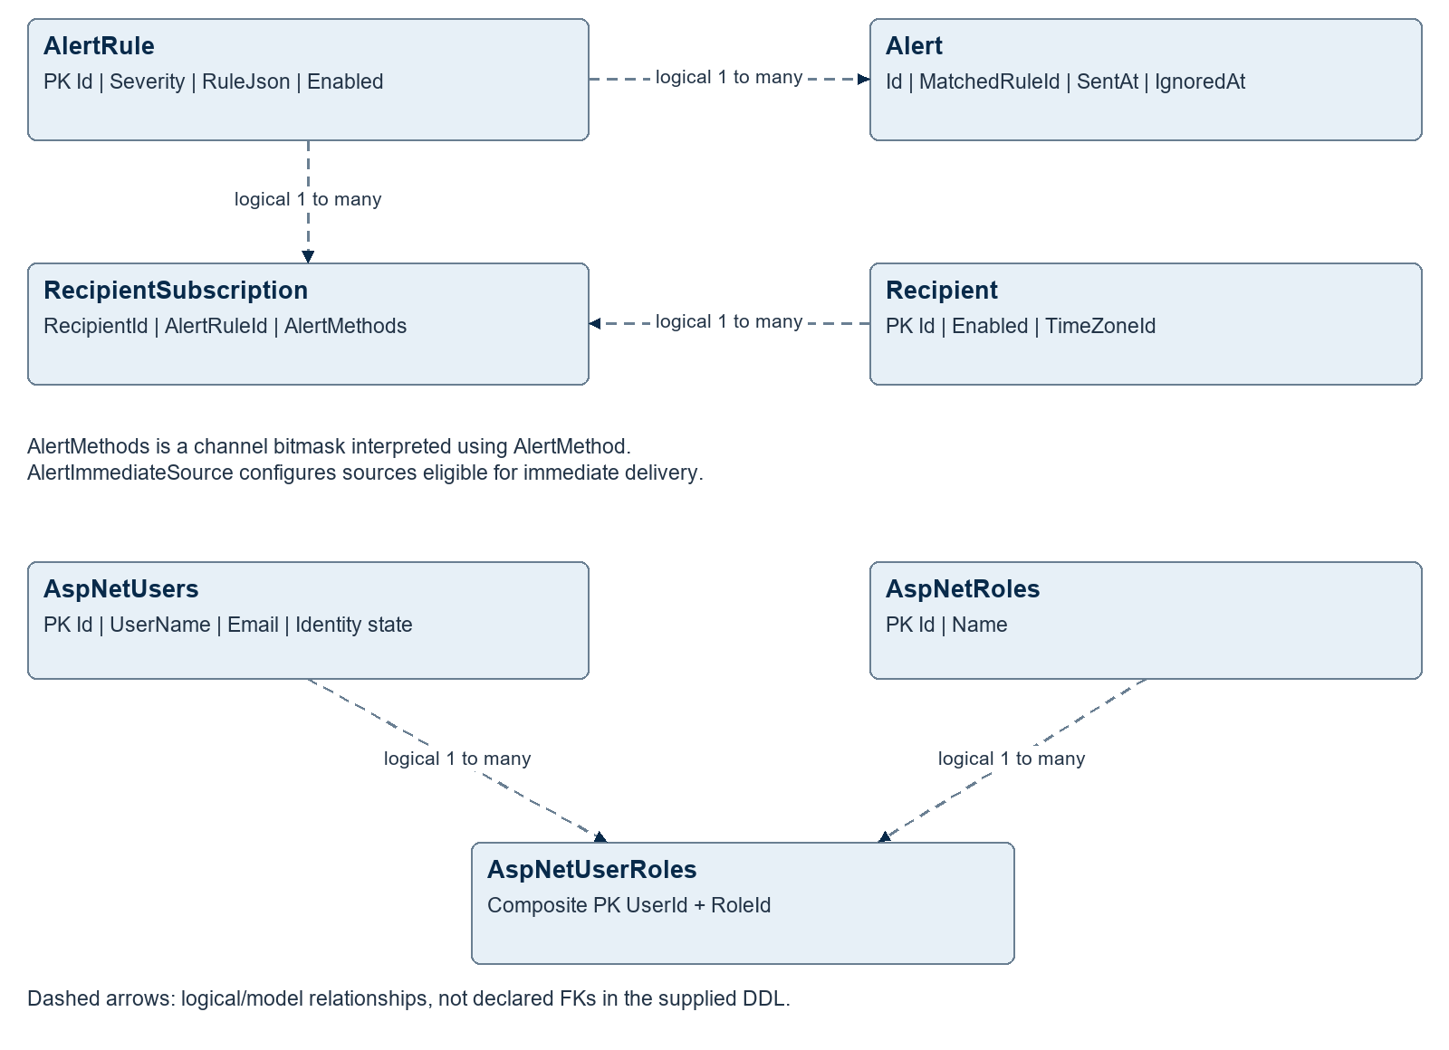
Figure 6 Logical alert subscription and identity relationships
Alert subscription and identity associations are shown as logical relationships because the reviewed create scripts do not declare their foreign keys. ASP.NET Core Identity models relationships through IdentityDbContext; the installed database must be checked separately. Additional identity tables store user claims, role claims, external logins, user tokens and ValidationToken. [S19, S21]

17 Service contracts and state transitions

Controller request and response
Contract field | Meaning
RequestId | GUID string correlating request and response
DestinationRole and DestinationServiceId | Role selection, exact instance selection, or both with consistency validation
Route and Method | Target-local API path and HTTP method
Token and Load | Forwarded bearer token and serialized request body
Attempt | Authentication retry counter, initialized to one
TransportSucceeded and HttpStatusCode | Routing/HTTP outcome, separate from trade execution status
Body and ErrorMessage | Returned serialized payload and transport error information

Trading request correlation
The execution service creates RequestRef for an order intent. OrderRequestDto carries it as OrderRefId; the broker ledger persists that reference and adds its own local order ID. Provider-side identifiers and BrokerRef are later recorded and returned in OrderStatusDto. AutoTradeSignal.Tag and OPEN/CLOSE OrderTag carry logical trade identity across the boundary. [S2, S10–S13]

Representative routed operations
Caller and target | Operation
AutoTrader to Broker ID | POST /order/new; POST /order/cancelasync; POST /order/status
Broker to ATS role | POST /api/autotrade/orderstatus
Admin to manager ID | GET status; POST start or stop under /services/{name}
Log router to Alert role | POST /api/alert/logrec

Signal START/STOP, BOT ACTIVE/SUSPECT/SUSPENDED, worker execution status and broker order status are separate state models. A stopped AutoTrade worker is not a broker cancellation or position liquidation. An HTTP success can still contain a business-level ignored or failed order status; callers must inspect the returned payload.

18 Operations and deployment

Startup and dependency order
A practical deployment sequence is SQL Server and required schemas first, then identity/admin hosting and the controller, then broker gateways and worker services, and finally operator validation. Controller clients include retry loops, so exact simultaneous startup is not required. Authentication URL configuration must avoid a dependency cycle that prevents initial service registration.
Service manager instances should be installed per managed Windows host with a narrow service allow-list and sufficient operating-system privileges. They can help recover application services, but recovery of the controller, identity host or manager itself also needs an independent mechanism. IBKR connectivity requires an available configured TWS/Gateway session.

Operational signals
Monitor | Why it matters
Latest PriceData and study timestamp | A connected process can still be behind the market
Device connection plus routed probe | Registry presence is different from reachability
NEW and in-progress order age | Detect unresolved submissions or callbacks
Broker positions versus local filled quantity | Identify execution or reconciliation discrepancies
BOT status and expiry rejections | Expose blocked allocations and stale signals
SQL notifications and Event activity | Detect a stalled database-driven pipeline
Alert backlog and delivery failures | Confirm that monitoring can reach operators

Configuration and release management
Service programs combine JSON settings, environment variables, command-line overrides and optional global variable substitution. A reloadable file does not imply every cached object automatically refreshes: some settings are captured at construction, some are periodically refreshed, and study plugin replacement requires restart. Treat configuration changes as operational changes with explicit refresh behavior.
The repository includes installer schema resources, migrations and SQL Agent archive/cleanup scripts. Apply migrations deliberately; full create/seed snapshots are not safe substitutes for an incremental update. Preserve active order and signal correlation during archiving and confirm recovery with a restored database before relying on retention procedures.

19 Security and resilience review
The following are code-based review observations and recommended validation work. They describe implementation boundaries and plausible failure modes; they are not results of a production penetration test or a live trading exercise.

Controller and management authorization
The hub requires authenticated service/admin roles, but registration accepts a requested service ID and routing accepts a target supplied by the caller. Verify that deployed identity policy binds each service principal to its allowed ID, role and destinations. The manager’s direct dispatcher also merits explicit command-level authorization because it does not pass through the HTTP authorization path. [S1, S17]

Exactly once execution and multiple instances
Database uniqueness and local locks reduce duplicate work. They do not create an atomic transaction across SQL Server and IBKR. Broker duplicate checks are separated from the external side effect, and role-only callbacks select one ATS instance. Before scaling execution across hosts, define durable ownership, atomic dispatch claims and reconciliation after uncertain submission. The repository contains AcquireAutoTradeAppLock, but no call site was found in the execution service. [S9–S12, S18]

Signal consistency and recovery
StudySignal advances lastRawTime during processing and catches transaction exceptions internally. Confirm that a failed commit cannot leave the in-memory study/signal cursor ahead of durable state. Simulate SQL failure at commit and verify replay produces the same persisted result without missing a signal. [S8]

Configuration and schema drift
Resolve the 10020-versus-20-minute expiry default, the futures-only synchronization branch, and the legacy namespace/README names. The common alert snapshot includes AlertImmediateSource and delivery enhancements that are not identical to the installer base schema. Verify migrations and unique indexes in the installed database instead of assuming a snapshot matches it. [S5, S9, S18–S21]

Credential and diagnostic handling
The platform includes encrypted configuration helpers and certificate settings, but their presence does not prove consistent protection of every secret. Review service account permissions, certificate validation, connection strings and logging. In particular, the admin program enables identity PII logging; the auxiliary DDNS program accepts all server certificates in its HTTP handler. These should have an explicit production policy. [S14, S22]

Notifications and failure visibility
SQL query notifications and recent Event scans are wake-up mechanisms; validate restart catch-up and prolonged disconnection behavior. Log forwarding is not durable, and alert dispatch may duplicate successful deliveries after partial failure. If operator notification must be guaranteed, add persistent delivery state and a durable producer buffer. [S4, S19]

20 Feature coverage and validation priorities
Capability | Implementation assessment
Service discovery and routing | Implemented with Device registry and SignalR hub
Role-based load balancing | First returned service only; no balancing policy shown
Market bar persistence | Implemented scheduled IBKR path; FUT branch restriction
Technical studies and signals | Implemented one-minute aggregation and plugin-based studies
Automatic trade execution | Implemented entry/exit intent, quantity handling and status tracking
Broker account distribution | Implemented explicit service ownership and account routing
Broker risk controls | Ticker permission, position limit and duplicate-order checks
Administration and monitoring | Implemented Angular console, admin API, status hub and log views
Service lifecycle operations | Implemented Windows start, stop, status and log commands
Remote software update | Future requirement; no updater command in manager
Additional broker providers | Abstraction exists; IBKR implementation is present
Central alert delivery | Implemented rules, recipients, SMTP and Pushover

Recommended verification sequence
• Verify each installed schema version, enabled SQL Service Broker, expected triggers and both execution uniqueness indexes.
• Exercise registration, disablement, reconnect and route failure with more than one service of the same role.
• Compare replayed studies and signals against known one-minute data, including revisions and database write failure.
• Use isolated broker test accounts to validate duplicate submissions, missing acknowledgements, partial fills, cancellation and restart reconciliation.
• Test manager recovery when controller or identity services are unavailable, and check unauthorized lifecycle requests.
• Run alert regression coverage and validate recipient time zones, partial failures and backlog expiry in the deployment environment.
These checks complement the architecture review. Acceptance thresholds for latency, freshness, recovery time and retention should be agreed for the actual deployment; the code alone does not establish service-level objectives.

21 Supporting projects and source map

Other projects in the solution
FIGBrokerSync is a separate web-service project with a broker-oriented structure and references to FIGCommon and IBKRProvider. Its name alone does not establish a separate synchronization responsibility; deployment ownership should be confirmed before treating it as an additional active core service. FIG_DDNS_Job is an auxiliary Windows-hosted dynamic-DNS job. FIGInstaller is a Windows Forms deployment wizard. FIGBacktestOptimizer contains offline CSV-based backtesting and parameter optimization code; it is not the live signal service. [S22]
MasterKeyEncryptionUtil and ReplaceTextTool are supporting utilities. FIGSignalCpp and study-related projects indicate additional analysis implementations, but the active FIGSignalSvc plugin contract is the relevant boundary for this architecture. These tools should be versioned and documented alongside the services they support.

Source references
Paths below are relative to the FIGCollection repository root. Each reference identifies the implementation units used for the associated description. SQL diagrams are derived from create scripts and model/repository relationships; installed schemas and running configuration require separate verification.
Ref | Source location
S1 | FIGControllerSvc/Hubs/ClientAgentHub.cs; FIGControllerSvc/Program.cs
S2 | FIGCommon/Models/FIGController/ControllerRouteRequest.cs; ControllerRouteResponse.cs; ControllerConfig.cs
S3 | FIGCommon/Services/ClientSignalRService.cs; ApiServiceBase.cs
S4 | FIGCommon/Services/EventMonitorService.cs; Services/LogMonitor/LogAlertRouter.cs
S5 | FIGPriceSyncSvc/Services/PriceSyncService.cs; PriceChangeMonitorService.cs
S6 | FIGPriceSyncSvc/Program.cs; Services/MarketDataTrackerService.cs; Model/MarketScheduleHelper.cs
S7 | FIGSignalSvc/Services/PriceMonitorService.cs; ExecStudySet.cs
S8 | FIGSignalSvc/Services/StudySignal.cs; Plugins/StudyPluginCatalog.cs; README.md
S9 | FIGAutoTraderSvc/Services/AutoTradeLiveService.cs; AutoTradeManagementService.cs; AutoTradeProcessLock.cs
S10 | FIGAutoTraderSvc/Services/OrderManagementService.cs; FigBrokerAPIService.cs; SignalMonitorService.cs
S11 | FIGBrokerSvc/Services/OrderService.cs; DataAccess/BrokerRepo.cs
S12 | FIGBrokerSvc/Services/OrderTrackerService.cs; ATSApi.cs
S13 | IBKRProvider/Service/Provider.cs; PositionTrackerService.cs; MainHost.cs
S14 | FIGAutoTraderAdminSvc/Program.cs; Controllers/; RootsIdentity/MainHost.cs
S15 | FIGAutoTraderAdminSvc/Services/ATSMonitorService.cs; DeviceMonitorService.cs; ServiceMgrApi.cs
S16 | FIGAutoTraderAdminConsole/package.json; src/app/app.routes.ts
S17 | FIGServiceMgrSvc/Program.cs; Services/ManagedServiceController.cs; ServiceManagerSignalRService.cs; Controllers/SignalRDispatcher.cs; ServicesController.cs
S18 | FIGInstaller/Resources/fig_autotrader_db.sql; fig_autotrader_signal_safeguards_migration.sql; FIGCommon/DataAccess/MainRepo.cs
S19 | FIGAlertSvc/Services/; README-delivery.md; FIGCommon/DataSchema/FIGAlert-Sceham.sql; FIGInstaller/Resources/fig_alert_db.sql
S20 | FIGInstaller/Resources/fig_broker_db.sql; FIGCommon/DataSchema/FIGBroker-Schema.sql
S21 | FIGInstaller/Resources/fig_user_db.sql; RootsIdentity/DataAccess/ApplicationDbContext.cs
S22 | FIGBrokerSync/FIGBrokerSync.csproj; FIG_DDNS_Job/Program.cs; FIGInstaller/Program.cs; FIGBacktestOptimizer/

Use footnotes for definitions, assumptions, or terms that need precision without interrupting the main narrative.

